Youchun Zhang

Thesis Studio 1

30 September 2018

Milestone Paper – Research

This thesis research is looking at how the algorithmic transparency affects the everyday lives and what are the current academic and legal reactions addressing this problem. The response to this topic would be to create an experience that models the dynamics in an algorithm-controlled system and reflects the necessity of the algorithmic transparency. The research is based on the domain of algorithmic transparency and the sub-domains including algorithm-controlled system, policy and ethics, security and Intellectual Property, and the main characteristics of the algorithm in order to make it transparent.



Figure 1: Domains of Interest

*What is algorithm?*

In a broad term, an algorithm is “a set of steps to accomplish a task” with given inputs and a correct solution.1 A GPS uses the “shortest-path” algorithm to find the route. Delivery companies use algorithms to assign packages to individual trucks and to determine the order of delivering packages. Web-based commerce uses algorithms to secure credit card information across the Internet.

There are several examples of algorithms that have affected all computer users and shaped the world that we are looking at today: the original version of the algorithm used by Google - PageRank to rank the most relevant matching documents at the top; public key cryptography to set up a secure session when the user connects online; pattern recognition algorithms which have been widely used for speech and face recognition; and data compression algorithms.2



Figure 2: Screenshot of a personalized YouTube homepage­­

Algorithms have been participating in the majority of the human’s daily activities. More and more decision-making processes have been replaced by algorithm processing. However, little attention has been paid to regulating the behavior of an algorithm-controlled system as what being regulated of a human.

In 2014, researchers from Facebook and Cornell University conducted a study of emotional contagion based on a random sample of Facebook users over a one-week period in 2012. It caused a heated discussion on ethics, legal policy, and psychological test standard.3 In 2018, top creators from YouTube reported that the creators burning out and breaking down issue was spreading.4 *Algorithm of Oppression* used Google search algorithm as an example, and pointed out that the algorithm reflects the biases and values among a large group, in which minorities can be rarely noticed.5 From Wall Street to Silicon Valley, the algorithmic control has gone beyond the money and information and penetrate into every aspect of the everyday life.6 In China, with 1.1 billion mobile internet devices and the privacy laws allowing a free-for-all with user data, the real-world activities of Chinese people are all captured and used for AI algorithm development.7­­

*Unbox the YouTube algorithm*

Elle Mills is a 19-year-old YouTuber. She joined YouTube six years ago. She has uploaded 154 videos since 2012. She has 1,513,841 subscribers and 124,544,412 views in total. Her latest video was updated 9 hours ago. The video “Burn Out at 19” was published four months ago with 1,598,013 views. The YouTube algorithm she is living with has three primary viewer factors – watch history, search history, and demographic information. In order for a video to be promoted by YouTube’s Browse, Suggested and Recommended features, the video must get through the Candidate Generation Filter and the Ranking filter. The goal of the algorithm is for YouTube to lead to longer viewing sessions.8



Figure 3: Screenshot of Elle Mills’ YouTube channel



Figure 4: The burnout process

In 2017, YouTube launched a beta product for creators. To better engage the creator with the platform, this studio product is equipped with all kinds of features as requested by creators. A cumulative chart shows the total views and metrics as the video is published over time. Statistics like “Audience retention” help provide insights into how well the video is keeping the audience watching.9

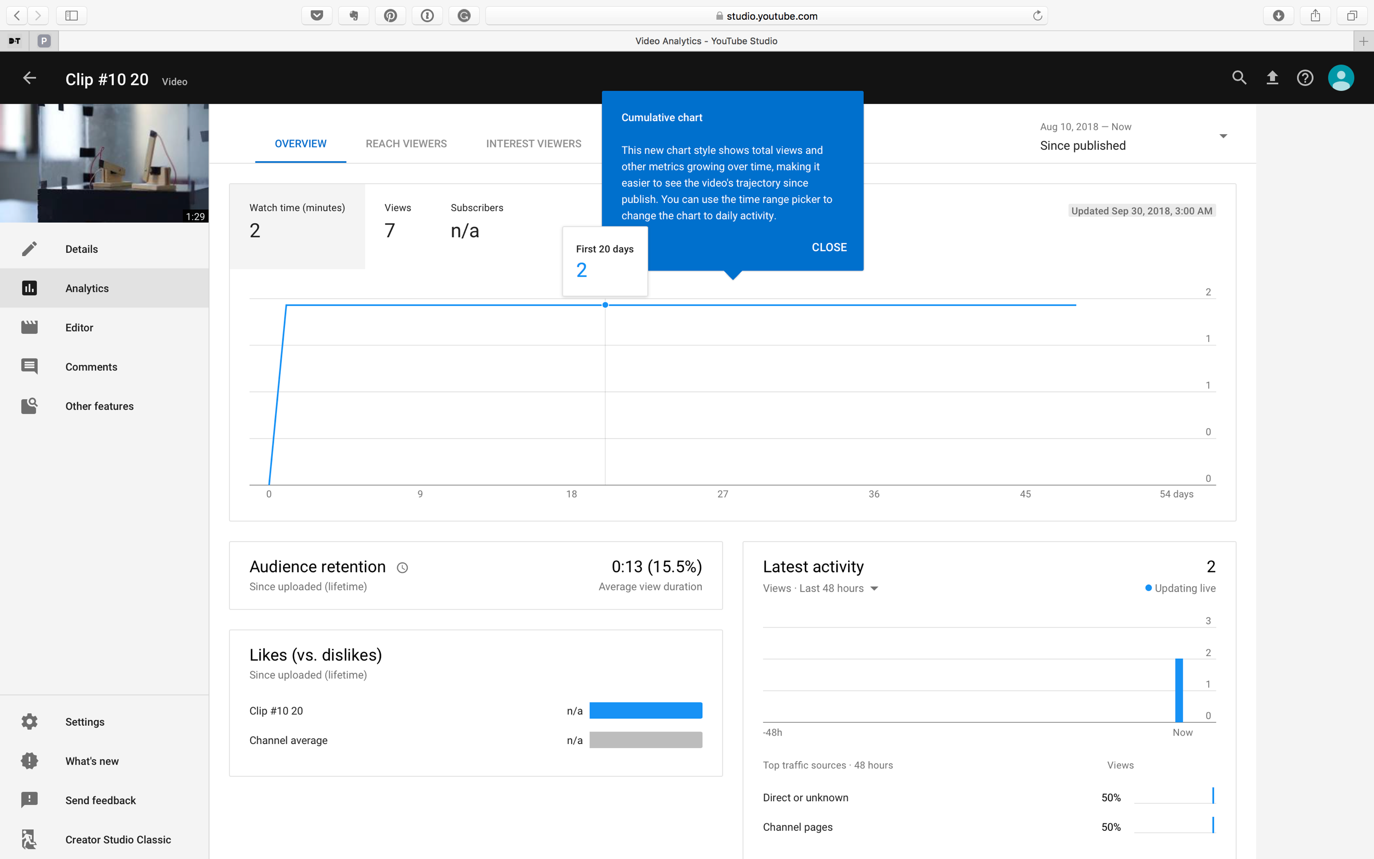

Figure 5: Video analytics

*Algorithmic Transparency – Resources & Precedents*

Michael Johnston from Colgate University defined "Transparency" as "official business conducted in such a way that substantive and procedural information is available to, and broadly understandable by, people and groups in society, subject to reasonable limits protecting security and privacy" in an article. 10 Nicholas Diakopoulos and Michael Koliska coined the phrase and defined algorithmic transparency as “the disclosure of information about algorithms to enable monitoring, checking, criticism, or intervention by interested parties”. 11

Kate Crawford from AI Now Institute and Viadan Joler from Share Lab created an anatomical map of Amazon Echo. Although the general audience often views the system and the interaction just as a combination of commands and responses, there are more underneath - chains of resource extraction, human labor, algorithmic processing, and logistics.12 The workshop on Visualization for AI Explainability at IEEE VIS uses visualization to illustrate how AI techniques work.13 Also, MIT Lincoln Laboratory is working on setting up a new standard for the algorithm to make the Artificial Intelligence system use human-like reasoning to solve problems.14

New York City Council met early on a law on algorithmic decision-making transparency. It could have real significance for the rest of the nation. New York is using the algorithm to determine the bail value for indigent defendants. As AI is pervasive throughout the world, artificial intelligence and big data analytics are increasingly replacing human decision making.15 EU Commission relates data protection law as part of the rights of citizens. Regardless of where the data is processed and where the company is established, one has the right to obtain access to the personal data held, to request that decisions based on automated processing concerning, to express the point of view and contest the decision.16

Works Cited

1. Cormen, Thomas H. *Algorithms Unlocked*. Cambridge: MIT Press, 2013.
2. MacCormick, John. *Nine Algorithms That Changed the Future: The Ingenious Ideas That Drive Todays Computers*. Princeton, NJ: Princeton University Press, 2013.
3. Kramer, Adam, Jamie Guillory, and Jeffrey Hancock. "Experimental Evidence of Massive-scale Emotional Contagion through Social Networks." Proceedings of the National Academy of Sciences, 2014, 8788 LP-790.
4. Alexander, Julia. "YouTube's Top Creators Are Burning out and Breaking down En Masse." Polygon. June 01, 2018. Accessed September 30, 2018. https://www.polygon.com/2018/6/1/17413542/burnout-mental-health-awareness-youtube-elle-mills-el-rubius-bobby-burns-pewdiepie.
5. Noble, Safiya Umoja. Algorithms of Oppression: How Search Engines Reinforce Racism. New York: New York University Press., 2018.
6. Pasquale, Frank. The Black Box Society: The Secret Algorithms That Control Money and Information. Harvard University Press, 2016.
7. Lee, Kai-fu. "What China Can Teach the U.S. About Artificial Intelligence." The New York Times. September 22, 2018. Accessed September 30, 2018. https://www.nytimes.com/2018/09/22/opinion/sunday/ai-china-united-states.html.
8. Covington, Paul, Jay Adams, and Emre Sargin. "Deep Neural Networks for YouTube Recommendations." *Proceedings of the 10th ACM Conference on Recommender Systems - RecSys 16*, 2016. doi:10.1145/2959100.2959190.
9. Cohen, David. "YouTube Unveiled YouTube Studio (Beta) at VidCon." – Adweek. June 26, 2017. Accessed October 01, 2018. https://www.adweek.com/digital/youtube-vidcon-creators-2/.
10. Johnston, Michael. Good Governance: Rule of Law, Transparency, and Accountability. 2018.
11. Diakopoulos, Nicholas, and Michael Koliska. "Algorithmic Transparency in the News Media." *Digital Journalism*5, no. 7 (2016): 809-28. doi:10.1080/21670811.2016.1208053.
12. "Anatomy of an AI System." Anatomy of an AI System. https://anatomyof.ai/.
13. VISxAI Workshop at IEEE VIS 2018. Accessed September 30, 2018. https://visxai.io/.
14. Foy, Kylie, and Lincoln Laboratory. "Artificial Intelligence System Uses Transparent, Human-like Reasoning to Solve Problems." MIT News. September 11, 2018. Accessed September 30, 2018. http://news.mit.edu/2018/mit-lincoln-laboratory-ai-system-solves-problems-through-human-reasoning-0911.
15. Powles, Julia. "New York City's Bold, Flawed Attempt to Make Algorithms Accountable." The New Yorker. December 21, 2017. Accessed September 30, 2018. https://www.newyorker.com/tech/annals-of-technology/new-york-citys-bold-flawed-attempt-to-make-algorithms-accountable.
16. "What Are My Rights?" Together Against Trafficking in Human Beings. August 01, 2018. Accessed September 30, 2018. https://ec.europa.eu/info/law/law-topic/data-protection/reform/rights-citizens/my-rights/what-are-my-rights_en.